Greg Grube
Remote Sensing
Lab 7 and 8

Introduction:
Horicon Marsh National Wildlife Preserve in east central Wisconsin and the areas surrounding it show a wide amount of diversity in land cover types. In this lab, my goal is to perform a classification of the Horicon Marsh and the surrounding area’s land cover in order to determine which areas are home to healthy vegetation and which are either built up areas or bare ground. To complete my goal, I am implementing a supervised classification scheme, where the image analyst determines pixel categorization by choosing examples training sites that correspond to each class. Once these training samples are collected, I will be using two supervised classification methods, the parallelpiped classifier and the maximum likelihood classifier. After performing these algorithms, I will analyze the map produced and the computed statistics to determine which classification is most effective. Finally, I will perform an accuracy assessment of the classifications using random independent test sites in order to determine sources of error and correct them to produce a higher quality map. This will ultimately allow me to make good decisions when discerning land cover classes from each other.
Methods:
When going about completing the unsupervised classification process, the first step is to choose classification categories to identify. In this case, the classes were water, wetlands, forests, grassland/ agriculture and urban/bare fields. For each of these, there were a number of classes that would narrow into them when completing the classification process. To complete this next step, I had to choose an algorithm to use to complete the unsupervised classification. In this case, the k-means algorithm was used. I chose 40 classes to look at with 5 for a threshold and 5 for the maximum number of iterations. I then ran the k-means algorithm, which produced a map featuring the 40 classes assigned. After overlaying the classification, I began the process of changing the colors and labeling the clusters. My strategy for doing this was to look for specific areas that could easily be differentiated from their surrounding and then using Google Earth and other band layers in ENVI, assigning these areas to a broad land type class. I found that the infrared and swir bands worked well for the purpose of looking for the land types initially and then using Google Earth to identify the specific features on the ground.
Trying to narrow down the 40 fields into 5 broad classes was a lengthy process. The first step that I took was to try and find the most obvious representative of each type of field. For example, I found the class that most exemplified a wetland, then found the class that was definitively urban, and so on. Once I completed this, I worked with the nearby classes to try and combine them into groups based on what they were most like. In the case of classes in the transition area between two categories, I was forced to choose which fit the best, even though in some cases, the area in question might have looked like part of both categories, or had very few pixels to be able to identify clearly. Once this process was complete, I was able to merge those areas together and select a color for each of the five classification categories to create a final map.
Results:
The five category classification map that was produced was helpful in describing the broad categories in the region near the Horicon Marsh. The first main category displayed is the water, which required no merging and was easy to spot in both the single band and multispectral images. Showing up a characteristic blue color, the main portion of the water was located in the center of the marsh, though there were also various lakes outside of the marsh. The wetland category is the nearest to the water and surrounds the body of water in the center of the marsh. This area constitutes a large area in the center of the map and represents the areas that show up as dark brown in a true color image. The third classification is showing the forests in the region. The forests are largely spread out in Figure 1, though they are found in large quantities near the wetlands. The forest category elsewhere in the image tends to show up in small groupings near cities or on the borders of agricultural fields. The fourth classification grouping in the map is the agriculture/grassland class. This yellow-green colored category makes up the majority of the map, at 55% of the total area. Grasslands and agriculture both show up as similar colors in the true color map as well as infrared and swir bands, making them very difficult to separate from each other with the amount of classes with a reasonable amount of classes. As a result, they are grouped together. The final category is what I classified as urban/bare ground. As with grassland and agriculture, urban and bare ground was difficult to separate and was grouped together. This category, as a result, shows up in Figure 1 in the cities, but also as bare agriculture fields and other bare ground in the region.
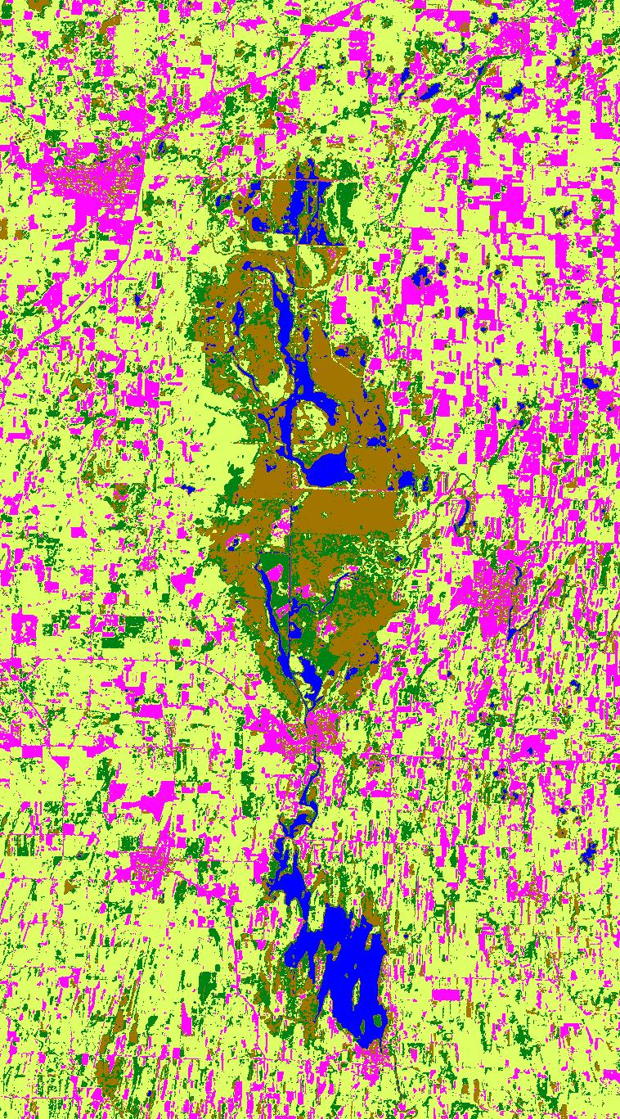
Figure 1: The map of the Horicon Marsh area produced using an unsupervised classification procedure. In the map, water is shown as blue, wetland as brown, forests in dark green, agriculture/grassland as yellow-green, and urban/bare ground as magenta.

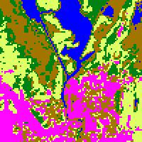

Figure 2: A 2x zoom of the map showing detail of the area near the city of Horicon.
File: horicon_km | eans_40cl s.bin [1,036,186 points]
Class Name | Npts | Pct
---------- | ---- | ---
Unclassified | [0] | 0.00%
Open Water | [31598] | 3.05%
Wetland | [108840] | 10.50%
Wetland | [0] | 0.00%
Wetland | [0] | 0.00%
Wetland Vegetation | [0] | 0.00%
Wetland Vegetation | [0] | 0.00%
Wetland Vegetation | [0] | 0.00%
Wetland Forest | [0] | 0.00%
Dark Forest | [0] | 0.00%
Forest | [0] | 0.00%
Forest | [0] | 0.00%
Forest | [0] | 0.00%
Forest | [0] | 0.00%
Forest | [132894] | 12.83%
Agriculture | [0] | 0.00%
Agriculture | [0] | 0.00%
Agriculture/Grassland | [0] | 0.00%
Agriculture/Grassland | [0] | 0.00%
Grass | [0] | 0.00%
Agriculture/Grassland | [571054] | 55.11%
Wet Grass | [0] | 0.00%
Grass | [0] | 0.00%
Grass | [0] | 0.00%
Wet Agriculture | [0] | 0.00%
Agriculture | [0] | 0.00%
Agriculture | [0] | 0.00%
Agriculture | [0] | 0.00%
Dying Agriculture | [0] | 0.00%
Light Agriculture | [0] | 0.00%
Light Agriculture | [0] | 0.00%
Light Agriculture | [0] | 0.00%
Very Light Agriculture | [0] | 0.00%
Soil | [0] | 0.00%
Dry Field | [0] | 0.00%
Bare Ground | [0] | 0.00%
Bare Ground | [0] | 0.00%
Urban/Bare Ground | [191800] | 18.51%
Urban/Bare Ground | [0] | 0.00%
Urban/Bare Ground | [0] | 0.00%
Urban/Bare Ground | [0] | 0.00%

Discussion:
During the process of completing the unclassified supervision, there were a few land cover classes that were difficult to map. The most notable of these was the agriculture/grassland class. This was extremely difficult to classify because of the amount of overlap that occurred within the vegetation classes. Initially, I wanted to classify both grassland and agriculture into separate groups, but as I worked with the data, I found that agricultural features were showing up in the middle of the wetland and grasslands were becoming part of the agricultural fields. The first step that I took to correct the issue was I moved from the initial 30 classes that I had assigned during classification and upped the number to 40. By doing this, I was hoping to see more distinct separation between the classes so that I could divide them easily. While these extra classes certainly provided a more detailed look at each class, there were still many of the vegetation classes that were showing up in both in grassland areas and in agriculture areas. The change did help, but because grass and agriculture were so similar both appearance and classification, I ultimately decided to combine the two classes into one category.
Another area that I had difficulty is trying to find the difference between urban areas and bare ground. Like in the grassland/agriculture problem, there was a large amount of overlap between the two classes. After I tried increasing the classes, there was more separation in some of the classes, but the color similarity between bare fields and buildings and roads makes it difficult to discern with a manageable number of initial classes. As a result, the best solution became to combine the two classes into one, at which time it was easier to separate the combined class from the other categories.
One final area that I had difficulty was when dealing with the wetland feature. Trying to define the borders of the wetland area was difficult due to the intermixing between it and the forest and grassland/vegetation classes. It was especially difficult to discern the type of features due to the coarseness of the image and the dark colors within the wetland. I ended up relying on Google Earth for much of the help, though this didn’t provide all of the answers. What ended up providing a good delineation was using the 4-5-3 RGB combination, and by adding the swir band, I was able to better pick out areas that had more water in them than with just the infrared band.

